I recorded the leaf visit order, the (α,β) window entering the leaf-parent, and where the cutoff occurred. The important events (the points that cause pruning) are:
- At leaf index 3 (C = 19): a β-cutoff happens — leaf 4 (D) is not needed under that local node.
(Cutoff line: 3, label C; pruned: D (4).)
- At leaf index 5 (E = 40): an α-cutoff happens — this causes two leaves (the rest of that sibling subtree) to be skipped.
(Cutoff line: 5, label E; pruned: F (6) and G (7).)
- At index 9 (I = 16): a β-cutoff occurs (no further leaves in that tiny branch to enumerate afterwards).
(Cutoff line: 9, label I.)
- At index 11 (K = 42): an α-cutoff occurs — it prunes the next two leaves under that sibling subtree.
(Cutoff line: 11, label K; pruned: L (12) and M (13).)
- At indices 15 and 17 (O = 27 and Q = 18): β-cutoffs occur while exploring the rightmost top subtree (they cause some subtrees further right to be skipped).
(Cutoff lines: 15 (O) and 17 (Q).)
Putting the cutoff lines together:
- Alpha-cutoffs: lines 5 and 11 (leaf labels E and K).
- Beta-cutoffs: lines 3, 9, 15, 17 (leaf labels C, I, O, Q).
(As a result of these cutoffs some leaves are never evaluated — e.g. the far right leaves T..X are not reached in this left→right alpha–beta run — but the exact set of pruned leaf labels is less important than the cutoff line indices you asked for.)
• Final value returned at the root = 42 (so the root chooses the middle top subtree which yields 42).
• Alpha-cutoff lines: 5, 11.
• Beta-cutoff lines: 3, 9, 15, 17.

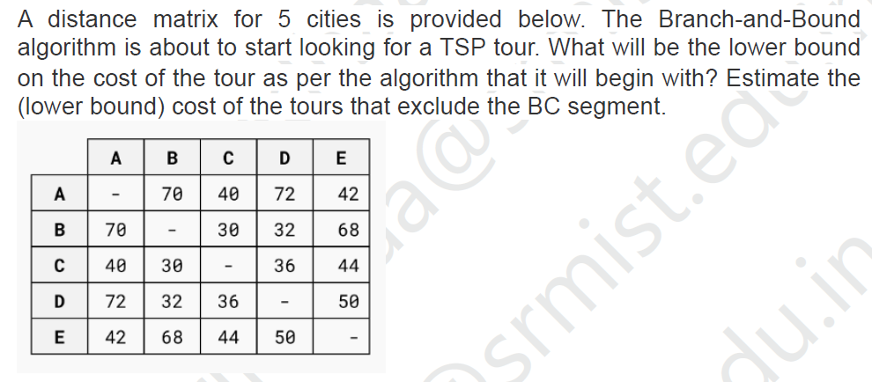

1) Initial lower bound (no exclusions)
Find the two smallest outgoing edges for each city:
- A: edges = {70, 40, 72, 42} → two smallest = 40, 42 → sum = 82
- B: edges = {70, 30, 32, 68} → two smallest = 30, 32 → sum = 62
- C: edges = {40, 30, 36, 44} → two smallest = 30, 36 → sum = 66
- D: edges = {72, 32, 36, 50} → two smallest = 32, 36 → sum = 68
- E: edges = {42, 68, 44, 50} → two smallest = 42, 44 → sum = 86
Total of all those sums = 82 + 62 + 66 + 68 + 86 = 364.
Because each tour edge was counted twice (once at each endpoint), divide by 2:
Initial lower bound = 364 / 2 = 182.
So the Branch-and-Bound algorithm will begin with a lower bound of 182.

2) Lower bound for tours that exclude the segment BC (i.e., edge B–C forbidden)
When BC is forbidden, for B and C we must pick their next best available edges (skip the BC = 30 entry).
Recompute the two smallest for B and C without BC:
- B: available edges then are {70(A), 32(D), 68(E)} → two smallest = 32, 68 → sum = 100
(previously was 30+32 = 62; forbidding BC forces 68 into the pair)
- C: available edges then are {40(A), 36(D), 44(E)} → two smallest = 36, 40 → sum = 76
(previously was 30+36 = 66; forbidding BC forces 40 into the pair)
A, D, E unchanged:
- A = 82, D = 68, E = 86 (same as before)
Total sum = A 82 + B 100 + C 76 + D 68 + E 86 = 412.
Divide by 2:
Lower bound excluding BC = 412 / 2 = 206.

Interpretation
- Initial lower bound (no constraints): 182.
- Lower bound for tours that exclude edge BC: 206.
Because excluding BC raises the lower bound from 182 to 206, any already-found feasible tour with cost < 206 would mean all BC-excluded subtrees can be pruned; otherwise those branches might still contain a better tour.

